- THURSDAY – EASY & RELAXED PLAN
- 🥐 7:30–8:30 am – Breakfast at Hotel
- No rushing out.
- Your daughter can eat calmly.
- Use this time to check weather (important for Mount Wellington).
- Pack water, light jackets.

- 🌄 9:00 am – Drive to Mount Wellington (Before It Gets Busy)
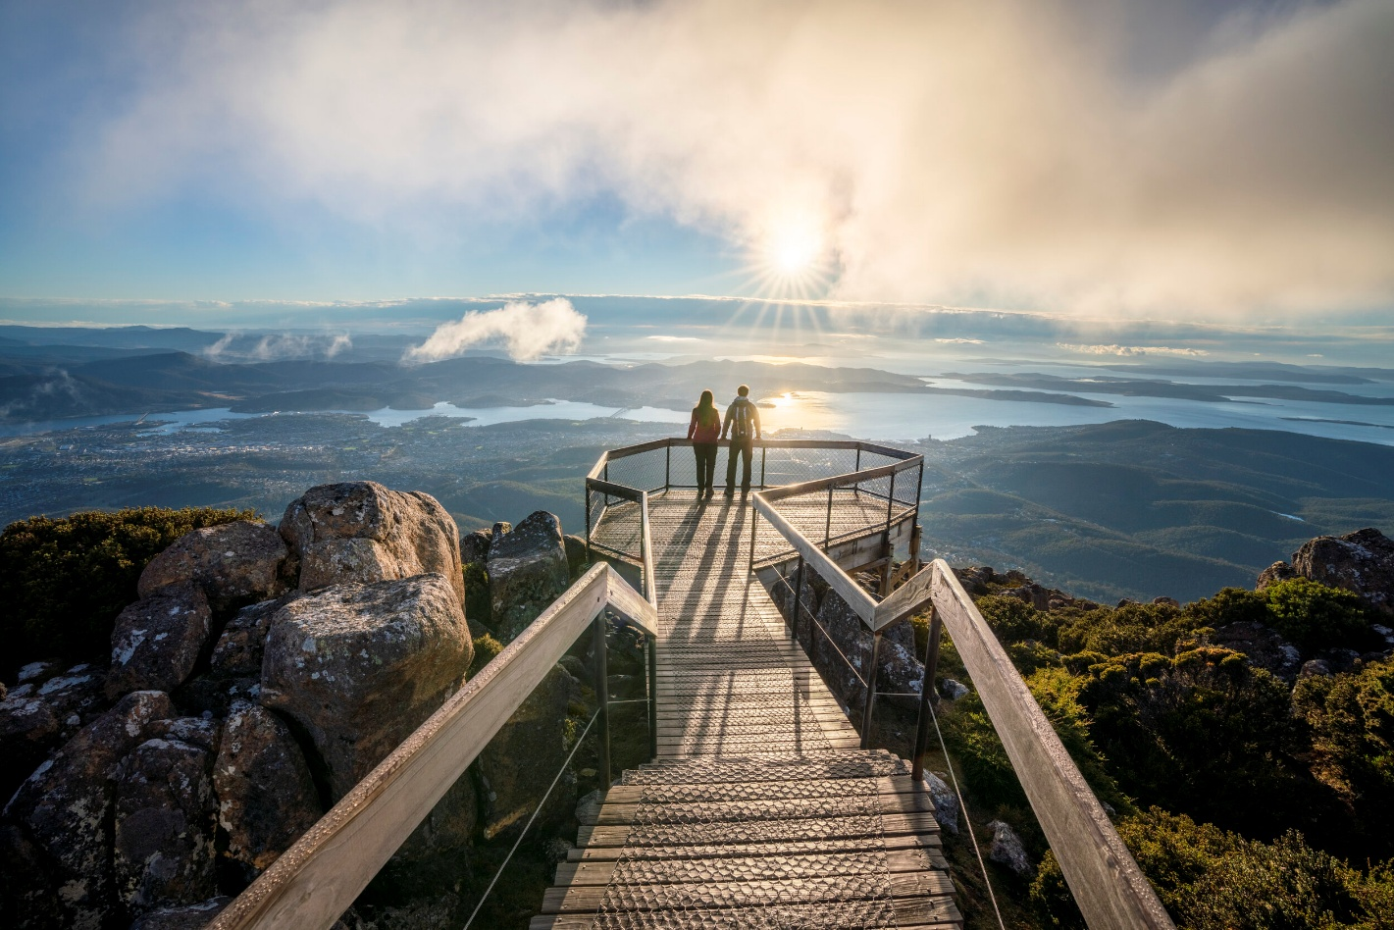

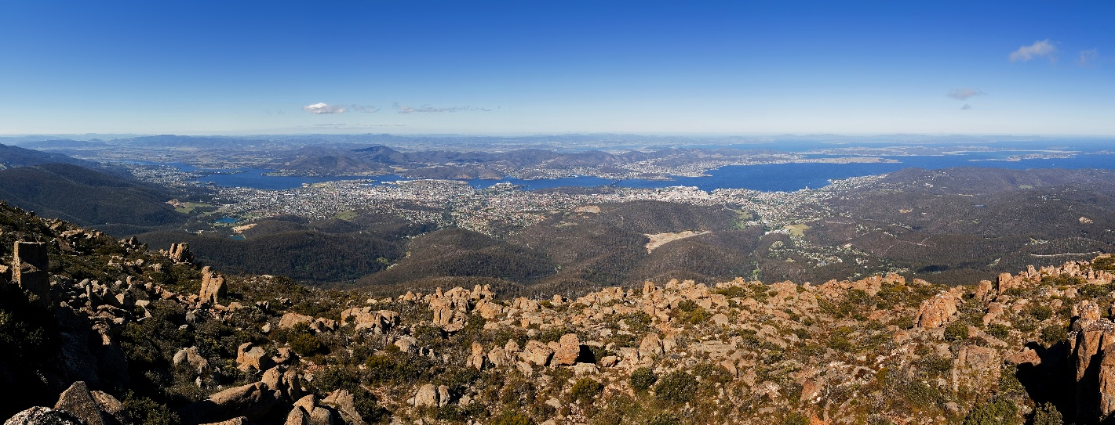
4
Visit Mount Wellington
- 25–30 min drive
- Park at summit
- 20–40 minutes total visit is enough
- Can be cold & windy — bring jackets
✔ Morning is usually clearer
✔ Less crowded
✔ Quick and impressive experience

- 🌊 11:00 am – Salamanca & Waterfront Walk
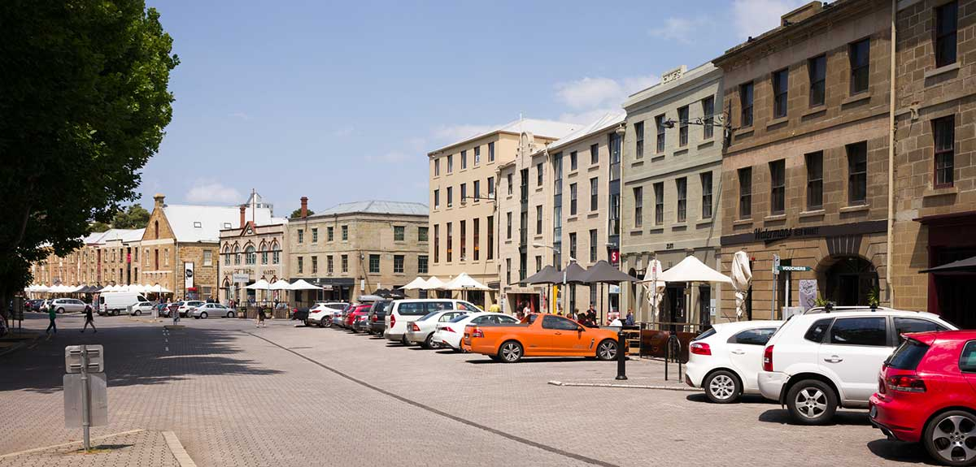
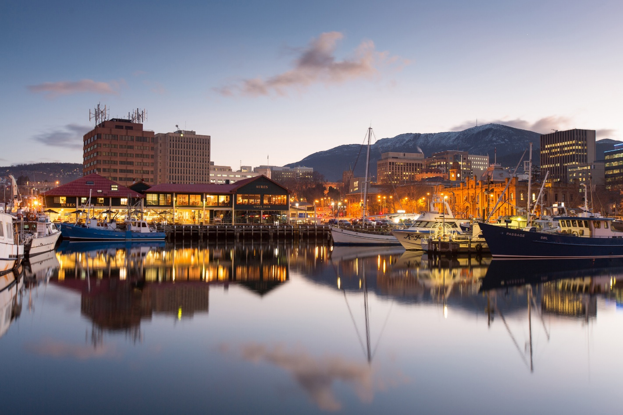
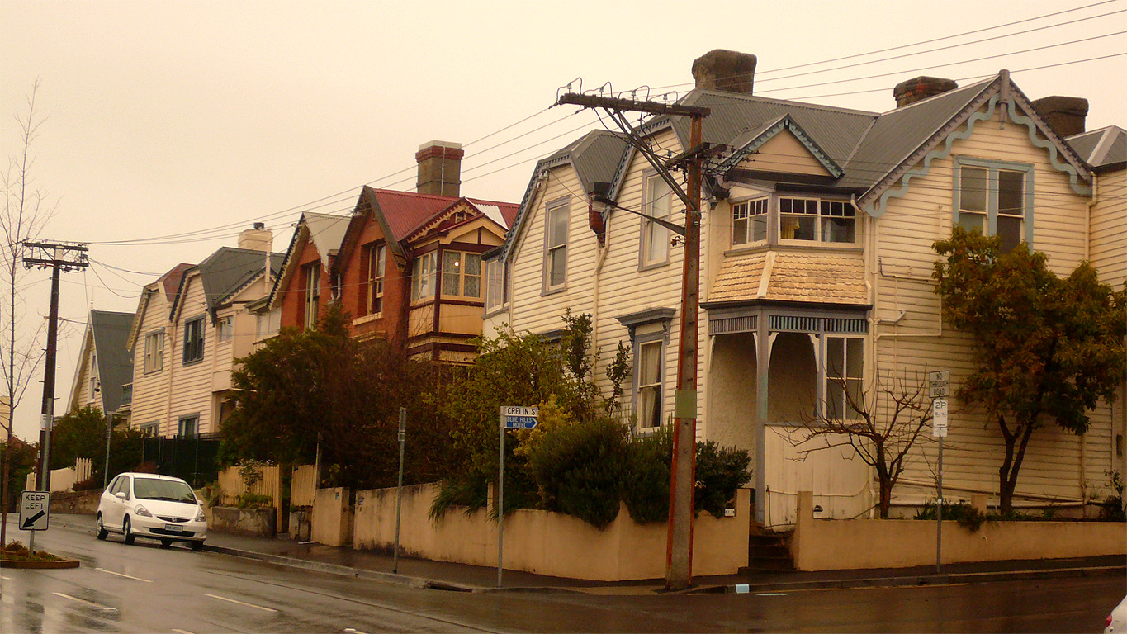
4
Walk around:
- Salamanca Place (no market, but still beautiful)
- Hobart Waterfront
- Battery Point (optional short walk)
Let your daughter walk freely — it's safe and open.

- 🍽 12:30–1:30 pm – Lunch
Waterfront fish & chips OR casual café in CBD.
Keep it simple.

- 🌿 2:00 pm – Botanical Gardens (Relaxed Afternoon)
Visit Royal Tasmanian Botanical Gardens
- Flat & easy walking
- Ducks & open grass
- Very relaxing before dinner
- 5–7 min drive from hotel

- 🍕 Evening – Dinner Near Hotel
Stay close to your hotel so everyone isn’t tired.
CBD has:
- Pizza
- Italian
- Asian
- Fish & chips
Early night — you drive to Launceston next day.

- Why This Plan Works Well
✔ No rushing
✔ Short drives
✔ Mix of views + walking
✔ Child-friendly
✔ Flexible if weather changes

If the weather forecast for Thursday looks bad, tell me — I’ll adjust it with indoor options 😊

Morning
Time | Activity | Notes / Travel
8:00 – 9:00 AM | Breakfast at Travelodge | Included at hotel
9:00 – 9:30 AM | Pack bag, get ready, leave hotel | Walking optional to Salamanca Place
9:30 – 11:00 AM | Explore Salamanca Place & Battery Point | Cobblestone streets, historic cottages, cafés. Walking distance from hotel (~12–15 min)
11:00 – 11:30 AM | Drive to Mount Wellington (Kunanyi) | ~25–30 min drive, parking available at summit

Midday
Time | Activity | Notes / Travel
11:30 AM – 1:00 PM | Mount Wellington stop | Panoramic views, short walks, photos. Easy trails for families
1:00 – 1:30 PM | Drive back toward city / hotel | Optional stop for light lunch in Hobart city or waterfront cafés

Afternoon
Time | Activity | Notes / Travel
2:30 – 3:30 PM | Royal Tasmanian Botanical Gardens | Open lawns, playground for your daughter. Driving ~5–10 min from city
3:30 – 5:30 PM | Hobart Waterfront / Docks stroll | Boats, ice cream, casual walk. Walking from Botanical Gardens possible (~15 min) or short drive

Evening
Time | Activity | Notes / Travel
5:30 – 6:30 PM | Return to Travelodge Hobart | Rest and refresh before dinner
6:30 – 8:00 PM | Bangkok city, Thai food Dinner at 29 Elizabeth St | Walking distance (~5–7 min from hotel)
- Tips for the Day
- Walking: Travelodge → Salamanca Place (~12–15 min), Travelodge → 29 Elizabeth St (~5–7 min)
- Driving: Mount Wellington and Botanical Gardens
- Packing: Snacks, water, comfortable shoes, light jacket for Mount Wellington
- Optional: Stop at Princes Park or Franklin Square if your daughter needs a quick play break

LAUNCESTON
- Friday – Hobart → Launceston (Travel & Afternoon Exploration)
Hotel in Launceston: Check-in 2 PM
Time | Activity | Notes / Travel
7:30 – 8:30 AM | Breakfast at Travelodge Hobart | Pack bags, check out by 10 AM
10:00 AM | Check out of Travelodge Hobart | Begin drive to Launceston
10:00 – 12:30 PM | Drive to Launceston (~2.5–3 hrs) | Stop for coffee/snacks along the way if needed
12:30 – 2:00 PM | Lunch en route or in Launceston | Options: casual café in Launceston CBD
2:00 PM | Check in to Launceston hotel | Settle in
3:00 – 5:30 PM | Cataract Gorge Reserve | Chairlift (optional), playgrounds, walking paths, suspension bridge. Family-friendly
6:00 – 7:30 PM | Dinner in Launceston CBD | Casual restaurants, family-friendly options

- Saturday – Launceston Full Day
Time | Activity | Notes / Travel
7:30 – 8:30 AM | Breakfast at hotel | Start early for sightseeing
9:00 – 12:00 PM | Tamar Valley / Platypus House & Seahorse World | ~1.5 hrs drive to Beauty Point area, see platypus, seahorses; kid-friendly
12:00 – 1:00 PM | Lunch near Beauty Point | Cafés nearby
1:00 – 3:30 PM | Continue Tamar Valley sightseeing | Optional: short winery visit (family-friendly with outdoor space)
3:30 – 4:30 PM | Return to Launceston | Relax at hotel or brief stop at city park
5:30 – 7:00 PM | Dinner in Launceston CBD | Family-friendly restaurant

- Sunday – Launceston & Departure
Time | Activity | Notes / Travel
7:30 – 8:30 AM | Breakfast at hotel | Pack bags, check out by 10 AM
10:00 – 12:00 PM | City Park & Launceston sights | Peacocks, playground, easy stroll with child
12:00 – 1:00 PM | Lunch in Launceston | Light meal / café
1:00 – 2:00 PM | Return car / relax | Hotel or nearby drop-off
2:00 – 4:00 PM | Buffer / souvenir shopping | Flexible in case of delays
4:00 – 4:30 PM | Head to Launceston Airport | ~15–20 min drive
5:00 PM | Flight departure | Ensure 1 hr prior arrival at airport

- ✅ Family-Friendly Notes
- Driving times: Hobart → Launceston ~2.5–3 hrs, Tamar Valley ~1.5 hrs one way.
- Kid-friendly activities: Cataract Gorge, Platypus House, Seahorse World, City Park playground.
- Meals: Flexible, casual cafés are best for a 5-year-old.
- Relaxed pace: Avoid over-scheduling; each day leaves downtime.

If you want, I can combine Hobart + Launceston into a single 3-page print-ready itinerary with timings, drives, and walking notes so you can carry it all in one document while traveling.
Do you want me to do that?

